[Subject line]: More Personalized News, Career Updates and Job Opportunities from [INSERT SCHOOL NAME]
[INSERT SCHOOL NAME] is partnering with Cerkl to change the way you receive our news. We know you’re busy and we value your time, so now you can access [INSERT SCHOOL NAME] news, career advice and job opportunities that are personalized and tailored just for you via a new newsletter powered by Cerkl. Be on the lookout for an email that looks like this:
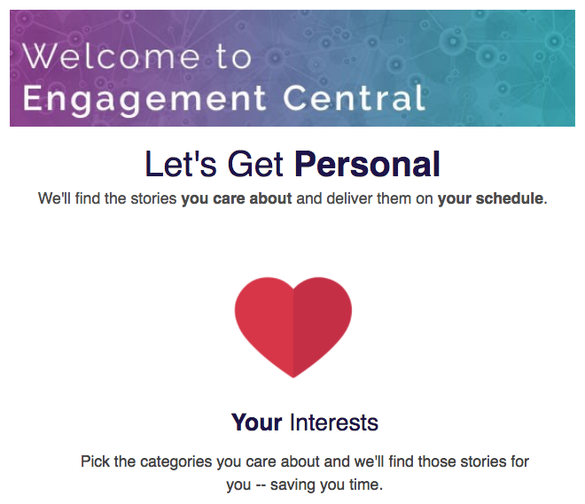

Then just tell us the types of stories you want to read and how often you want to receive the newsletter by updating your preferences when you receive the above welcome email.
We’re looking forward to providing you with the jobs, advice and news you care about most!

Sincerely,

[INSERT SCHOOL NAME]

